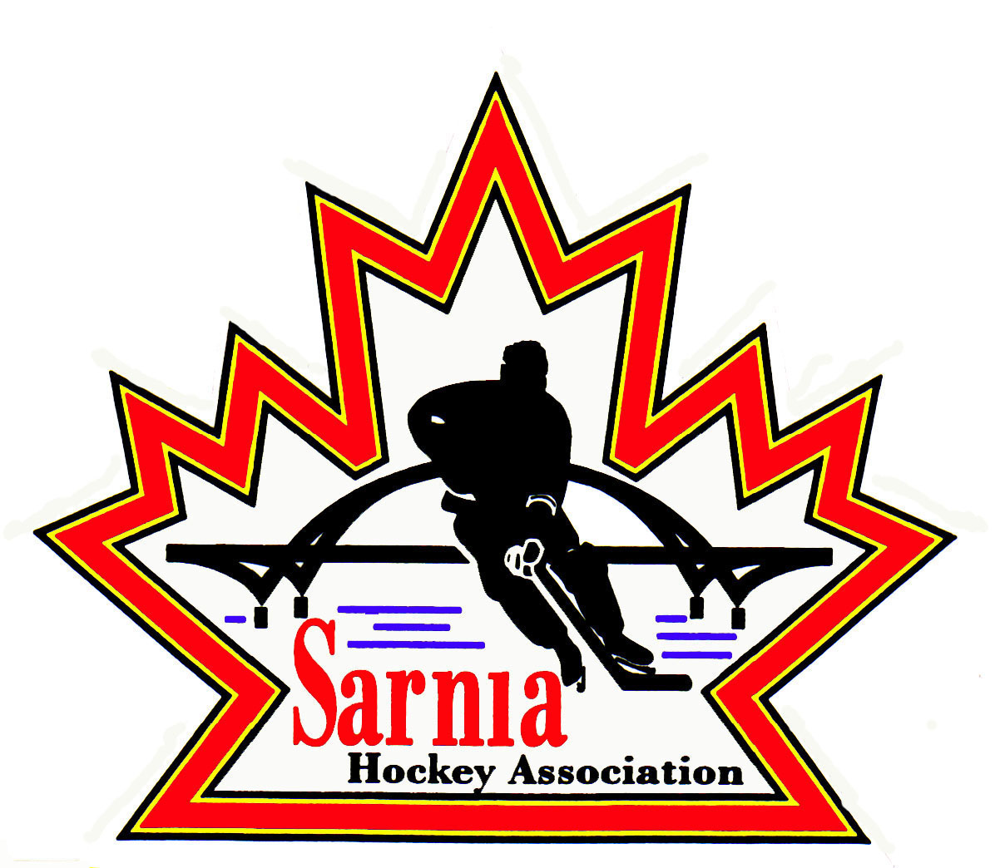

Sarnia Hockey Association

Minutes | Date: MAY 21, 2025 | time 7:00 pm

Meeting called by | Paul Walsh, President
Type of meeting | Regular
Secretary | Kelly Lane, Recording Secretary

Welcome | Paul Walsh, President, and meeting Chair welcomed everyone and called the meeting to order at 7:08 pm.

ATTENDANCE | Jacquie Beasley, Alister Brown, Emily Brown, Paul Douglass, Chuck Ewart, Pat Forbes, Ryan Gruntz, Kelly Lane, Cris LaPointe, Linda Lauzon, John Mellor, David Penner, John Ritchie, Wayne Scarrow, Tim Turner, Barb Walsh, Paul Walsh  Regrets: Heather Amaral, Andrew Beasley, Jerry Bernardo, Terry Gray, Dan Hunt, Bonny Marcy, Kyle Mellor, Blake Morrison, Ted Pendle

ACCEPTANCE OF MINUTES | MOTION #250521-001  “That the Minutes from May 6, 2025, be accepted as presented.” ( J. Mellor/Lauzon)  Carried

TREASURER’S REPORT | - An initial meeting with Pat Forbes in his new role of Assistant Treasurer has taken place.  - Pat will be taking on the following tasks:  - Benevity Grant tracking and fielding of team emails. Funds will be transferred by the Treasurer based on reports he monitors.  - Team Bank Accounts – Assistant Treasurer will be the liaison between teams and RBC for initial set up and first point of contact for any issues during the season.  - Ref/Timekeeper payment files beginning this fall will be created monthly by the Assistant Treasurer, reviewed//released by either Referee Director or Treasurer. He will be point of contact for tracking funds and fielding questions from teams. Funds will be moved by Treasurer.  - Team Bank Accounts – RBC has asked for rep team personnel to understand it can take a week or so to get an appointment set up. The process will be as efficient as we can make it.  DRAFT BUDGET PRESENTATION:  - Thanks to those that submitted budget information to assist in this process. Those amounts were included unaltered with the exception of Skills, resulting in the removal of any goalie development expenses presumed to be funded by the Cousi Committee.  - We extracted goalie development expenses that we assume will be grant funding from Cousi.  - Budget 2025/26 is based on the assumption that we will fill the following number of Recreation Teams:  - Foundations – 4 teams of 26 players  - U7 – 6 teams of 17 players  - U9 – 8 teams of 19 players  - U11 – 8 teams of 17 players *  - U13 – 8 teams of 17 players  - U15 – 6 teams of 18 players  - U17/18 – 4 teams of 18 players  - U18/20 – 4 teams of 18 players  *U11  - If we fill 8 teams in U11, we may not be able to have weeknight games for all 8 teams due to ice constraints. This past season we had only 6 U11 teams and now we are unable to add any more games on the same night due to ice constraints. Options were discussed such as having one game on another night or weekend or only having 6 teams in this division. There was consensus that we want to continue with 8 teams in this division so the Ice Scheduler and U11 Convener will work out this schedule.  - Budget includes 19 Rep Teams:  - 1 - U8 MD  - 2 - U9 MD  - 2 - U10 A & B  - 2 – U11 A & B  - 2 – U12 A & B  - 2 - U13 A & B  - 2 - U14 A & B  - 2 - U15 A & B  - 2 - U16 A & B  - 2 - U18 A & B  - Budget is based on 626 General Recreation, 104 U6 Rec, 140 U16/20 Rec, 138 AA and 189 MD/BB participants which totals 870 Rec participants and 327 Rep participants.  - Prior budget was based on 519 General Rec, 120 Foundation, 111 U16/20 Rec, 138 A/AA and 190 B/BB participations (Rec 750, Rep 328).  - The budget being presented is based on the key assumption that we hit these registration targets. Lower than anticipated registration may result in the presentation of an amended budget mid fall to scale back discretionary expenditures.  - Looking at 5% increase in expenses from last season. Ice and uniforms are the biggest items, along with referees/timekeeper expenses.  - Tim Hortons is no longer sponsoring U9 Rec Division so need to add socks and jerseys costs. We have added sponsors to cover off this with revenue.  - Due to higher than anticipated ice costs this past season, the budget does not include the application of surplus revenue to help lower registration fees.  REGISTRATION FEES:  - The proposed registration fees result in an increase across all Divisions.  - Increase of $50 for Foundations, U7-U16 Rec and U16/21 Rec.  - Increase of $250.00 for Representative players.  RECREATION:  - Foundations - $400.00  - U7-U15 - $700.00  - U16/21 - $500.00  REPRESENTATIVE:  - Fees - $2,000.00  - This $2,000.00 registration fee was built into the system as an anticipatory fee prior to tryouts to facilitate the new rostering process.  LATE FEES:  - Late fee of $100.00 is proposed for General Registration (U7 to U15) as of August 1. This is a decrease from last year’s $250.00 late fee.  MOTION #250521-002  “To approve the Registration fees of $400 (Foundations), $700 (General Rec Registration), $500 (U16-21 Rec) and $2,000 (Rep) and a $100 late fee applied to General Registration as of August 1.” ( E. Brown/Forbes)  Carried  MOTION #250521-003  “That the Sarnia Hockey Association 2025/26 Budget be approved as presented.” ( E. Brown/B. Walsh)  Carried  - There will be a payment plan similar to last year. Registration fees can be paid by etransfer or credit card.  - Cousi has earmarked $8000 to help support player assistance as well as YRASP which is County funded program for those players that qualify.  - First Shift program is not providing ice costs so $400 will need to be added to the budget.  - U18-21 Rec program – difficult to field teams if ages are separated out. We reduced # of teams this year.  - iPads are being upgraded as needed.  COUSI COMMITTEE:  - Cousi Committee is a group of hockey enthusiasts dedicated to raising funds to support SHA goalie development. They are starting their fundraising activities for the next season.  - Last season, just over $30,000 was made available to SHA for goalie development.  - Goalie coaches went to shared ice practices to provide goalie specific coaching (2 sessions each).  - PD Day Goalie camps took place focusing on skating, edgework and drill stations.  - Rec families with goalies received up to $100 reimbursement for goalie equipment they purchased.  - Subsidy was made available for any player requiring some financial support with registration regardless of the position they played.  - The program was well received and sessions sold out quickly and we have seen several goalies move from Rec league onto Rep teams both within SHA and in the County.  - The Cousi committee was thrilled with the progress with our first pilot year.  - The primary means of raising money is through their annual Golf tournament (Cousi Open) scheduled for July 26 in Mooretown. The Committee has lost some key volunteers this season and the committee is asking for SHA support. Anyone interested in coming to a Cousi meeting, let Emily Brown know and she can provide date/time. Other ways to help include event day volunteer, making some sponsorship calls on behalf of the committee and entering a team of 4 to play in the tournament.  - There are some goalie parents who will be asked as well as SHA Board members.

BILLS TO BE PAID | MOTION #250521-004  “That the bills be paid as presented.” (E. Brown/Scarrow)  Carried
  Recipient | Expense | AMOUNT
  Bluewater Referee Association  All Seasons Trophies  Canada Post  Alliance | Tryout Exhibition games  U8 Jamboree replacement awards  Annual Post Office Box renewal fee  Final team reconciliation | $ 703.00  $ 44.08  $ 211.31  $ 377.70

SELECT | - Proposing to run U10, U11, U13, U15, and U18 Select Teams this season.  - Select Director feels there is enough interest and skill.  MOTION #250521-005  “That SHA have U10, U11, U13, U15 and U18 Select Teams for the 2025/26 season.” ( Ritchie/Douglass)  Motion was rescinded until the SHA policy is changed.  - There was discussion about whether there would be enough teams to play in U10. It was noted there were 5 teams in the Kitchener area. There was also a question as to whether we have enough ice to accommodate another team.  - It was noted that SHA needs to do something to protect Sarnia’s players. We had people from other centres trying out for our rep teams and taking positions. This was happening in U9/U10. U10 has 8 Petrolia kids on the team. It was felt that having a U10 Select team will help us develop our players.  - Our BB teams lost a lot of players to the County in our older age groups.  - We will revisit our number of out-of-town players next year for our younger aged Rep Teams.  - The lack of ice to offer for our programs also hurts us in our development.  - We saw players come back from AAA this year due to open borders.  - We could consider AA, A and B team in future years to help protect our players.  - We only have 1 goalie for U10 B. Adding a select team could be a challenge.  - Could we do a shared ice practice for U10 and U11 Select teams to offset issue with ice availability.  - U18 Select is based on numbers.  - The process for Coach Interviews has to follow policies.  - There is a lot of positives to moving up the coach interviews to an earlier time as it is hard to get individuals to do interviews later in the season.  - This would be a change to our policy so we will need to go through PRAC and make the change.  - It will be a revamp of the policy and next step is to assign a PRAC.  - Need to use wordage of “potential” teams when advertising coaches for Select.

REGISTRAR | - Discussion about when to open and close registration.  - On proposed budget, we used June 1 to July 31 and August 1 for late fees.  - We are in the process of training our new Rec and Rep Registrars on the HCR.  - Registration catalog is there, and we have to mirror it.  - We feel we can be ready by June 1.  - No late feels for U16-20 Rec or Foundations.  MOTION #250521-004  “That SHA open Registration on June 1 to July 31 (if ready) and waiting list and late fees will take effect on August 1.” (Scarrow/Douglass)  Carried  - We can start advertising registration on Facebook as it was positive last year.

Photography DIRECTOR | - Photography Director wants contact info for U6/7, U18-21 of the players on the provided list so they can be contacted to arrange for photo pickup or delivery.

CORRESPONDENCE | - We received correspondence from Progressive Auto Sales. They want to put the same logo that is on OHL Sting sweaters on our rep team sweaters. This logo will also be on AAA and Lady Sting. They are willing to pay $400 per rep team for a total of $7,600.00. Jake Bourrie from the Sarnia Sting also approached us about this.

NEW BUSINESS | ALLIANCE AGM:  - Alliance AGM is scheduled for June 20-21 at Four Points Sheraton in London.  - Golf at Fire Rock on June 20 with dinner following at the hotel.  - June 21 is the AGM meeting from 8:30am to noon.  - If interested in attending, please contact Paul Walsh.  - We are allowed 10 delegates on a first come first serve basis.  - Registration deadline is May 31.  ALLIANCE NOTICE OF MOTIONS:  - These motions require input from our Board so SHA representatives attending the Alliance AGM can vote accordingly.  Alliance Motion 2025-01  The Alliance Hockey Officiating Working Group is proposing that the 4 official system be implemented for all U16 A/AA games.  If centre uses 3-man system which is mandatory at Rep U13-16 A and U13-U14 AAA, the referee must be certified at Level 3 or higher. The other 2 officials must be certified at Level 2 or higher. All officials must be at least 2 years older than the division age limit. For development purposes some Level 2 officials may be assigned to referee in a 3-official system.  All in favour: Carried - 9 for and 4 abstained  Alliance Motion # 2025-02  This is a Housekeeping adjustment with respect to the Duties of the Chair of Rep and Rec Council.  The Chair of the Representative Council will serve on the Board on behalf of the Representative Council. The Representative Council is responsible for and controls the daily operations of the Alliance Hockey Representative Member Associations.  The Chair of the Recreational Council will serve on the Board on behalf of the Recreational Council. The Recreational Council is responsible for and controls the daily operations of the Alliance Hockey Recreational Member Associations.  All in Favour: Carried  SHA POLICY 2.07 INVESTIGATION PROCEDURE:  - This procedure has gone through the Management of Change, and we did a Review Committee. This is the final review via email. Board members are asked to review the Policy, and it will be voted on at our next SHA meeting. If Board Members have any comments, they can contact Barb Walsh.  MANAGEMENT OF CHANGE PROPOSAL FOR SELECT HOCKEY:  - Policy 2.03 required to be reviewed to allow coach selection to move the process up.  - 4.16.07- Tryouts moving up to after Labour Day weekend.  - Exemption committee for illness or injury for tryouts.  - Tournament rule adjustment - 4.16. 11 paragraph 3. We are running Rec games during the week so no conflicts.  - Procedure with changes will be sent to PRAC committee consisting of Jerry Bernardo, Chris LaPointe, Pat Forbes, Paul Walsh and Chaired by Barb Walsh.  BOARD POSITIONS:  - Policy change discussed regarding Vice-President of Rec. We want to change the policy to have only served on SHA Board for 1 year only so we can fill that position.  - We can put this on the next agenda and will send note on proposal so that we can review it at our next meeting.  NEXT MEETING:  - Next meeting is Tuesday, June 3, 2025 at Clearwater Lower Hall.

adjournment | MOTION #250521-005  “That the meeting be adjourned.” (Walsh/Scarrow)  Carried

Paul Walsh Kelly Lane
President Secretary

